## Basics

* operating system
* free
* open source

### parked topics:-

internal working of command

### History

Ken Thompson 1970s UNIX

MULTICS

UNICS

Unix

GE to AT&T

PDP 7

Dennis Ritchie C

Brian Kernigham

Linus Torvalds 1990s Linux

Richard Stallman open source

### open source

1. sell the ice cream, recipe private
2. sell the ice cream, recipe public
3. ice cream free, recipe private
4. ice cream free, recipe public

source code open

firefox

VLC

GIMP

Blender

Audacity

Wordpress

Linux

### standards

sys V

BSD

### Unix based

BSD Unix →

Next

Darwin

Solaris

AIX

HP-UX

Xenix

Free BSD

### Linux based

Red Hat

BOSS

Mint

Fedora Core

OpenSuse

Debian Linux

Ubuntu

Kali Linux

kernel

## Linux Architecture



### File architecture

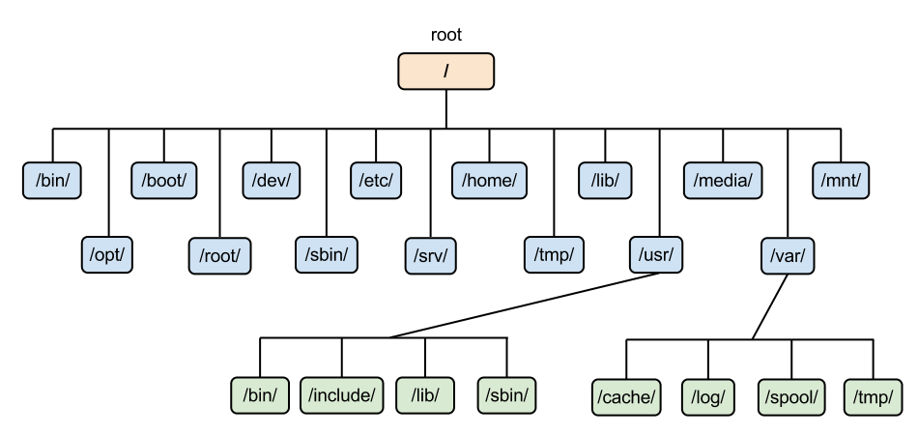

inverted tree structure

/

/home/john

/root

## Shell

* command line interface
* cli (command line interpreter)
* terminal

sh

ksh

csh

tcsh

zsh

Fish

bash

### tcsh

csh (UNIX C shell)

tcsh

### prompt

username@hostname folder

$ normal user

>

# root

### command

command options arguments

command arguments options

* fundamental unit
* code
* executable
* spawn a new process

### builtin

* executed by shell itself
* not a new process
* (not fetching the code from somewhere else)

cd, echo, export, alias, type, history pwd

## Basic commands

ls

-a

-l

cd

change directory

cd Videos

.. parent

cal

-y

date

clear

bc

pwd

print working directly

## help

whatis

- - help

apropos

### man

q

/text search “text”

n

shift+n

## Files & Directories

### files

* basic unit of data storage
* text files

.py

.c

.c++

.sh

* binary files

### directories

* relative paths
* absolute path
* home directory for every user

cd

<dir>

.. parent

. current directory

~ home directory

mkdir

make directory

## user & groups

* directory for every user

## scripting

.rc

configuration files

resource control

(run commands)